Flight Delay Prediction Using Deep Learning
Group 6

Abstract— Flight delays continue to frustrate travelers, especially at major airports like JFK where congestion and operational challenges can fluctuate throughout the day. Predicting delays can help passengers plan more confidently while also supporting airport operations. In this project, several deep learning models were evaluated to forecast short-term departure delays at JFK Airport. Models are trained using a dataset of 1-hour averages and 15-minute averages to compare how different dataset preparation and size affects model performance. Six architectures were explored: a 1D convolutional neural network (CNN), a simple RNN, LSTM and GRU networks, a Temporal Convolutional Network (TCN), and a Transformer model. Performance was compared using MAE, MSE, and RMSE. The results show that the temporal resolution of the data has a major impact on how each model behaves. TCN performed best on the hourly data but dropped significantly on the 15-minute dataset, while LSTM, GRU, and Transformer models remained relatively stable. These findings highlight not only how sensitive deep learning models can be to preprocessing choices, but also how careful time-series design can substantially change forecasting outcomes.

Introduction
When booking a flight, typically plans are centered around the scheduled departure and arrival times – such as transportation, connections, meetings, and hotel check-ins. However, flight delays are very common. In 2024, 1 out of 3 flights were delayed in the United States [1], creating stress and uncertainty for passengers as it becomes difficult to know whether plans are reliable.
This leads to the central problem statement: Flight delays create uncertainty for passengers, making it difficult to know how early to arrive at the airport. This project will use the Flight Delays Dataset to predict flight delays to provide recommendations for optimal airport arrival times. The motivation behind this project lays in the idea that delay predictions could reduce some of that uncertainty. If it can be estimated in advance whether a flight is likely to be delayed, travelers will have an opportunity to make more informed decisions in advance. For airlines and airports, understanding the patterns and factors associated with delays can support more proactive planning, staffing, and communication with passengers, which may improve both operational efficiency and customer satisfaction.
The project uses historical flight records from the Flight Delays Dataset to build predictive models of average departure delay at JFK. The performance is evaluated using error measures in minutes, such as mean absolute error and root mean squared error, comparing predicted and actual hourly departure delays. At the end of the project, the best-performing modeling approach will be identified, and the way it learns patterns will be evaluated.

Dataset and Preparation
The dataset used contains scheduled and actual departure and arrival times, aircraft type, airline, flight number, distance, delay reason, and delay duration. At first, the delay values were aggregated to compute the average delay for each hour across an entire year. This hourly dataset provides a high-level view of airport congestion that captures general peaks and troughs throughout the day. However, because each day contributes only 24 data points, the dataset was relatively small for deep learning. In addition, large outliers such as flights delayed two or three hours, affected the averages, which risked overshadowing normal patterns.
To address this, the process was repeated using 15-minute intervals. This produced four times as many data points while also smoothing out extreme values more consistently across smaller windows. Since deep learning models typically benefit from having more data, the 15-minute version provided an opportunity to reduce underfitting and potentially uncover finer-grained temporal patterns.
After aggregation, all categorical features (such as airline and aircraft type) were one-hot encoded. Irrelevant features or features that would not be known by users of the application (e.g. Actual Arrival Time) were dropped. Numeric features were scaled with StandardScaler to ensure that each input dimension contributed proportionally during training. Further features were engineered to aid in model prediction, including time-related features, rolling averages, and lag features. These features were chosen using general domain knowledge and practical application.
The post pre-processing dataset consisted of the following features: Time Interval (1 hour or 15 minutes respectively), Delay Minutes (target), Flight Count, Hour of Day, Day of Week, Month, Is Weekend, Is Holiday, 3 Hour Rolling Average, 24 Hour Rolling Average, Delay Same Time Last Week.
Once the dataset was fully processed, a sliding window was used to convert it into supervised sequences. Each window of past observations was used to predict the delay in the next interval. This created a dataset that all models could use.
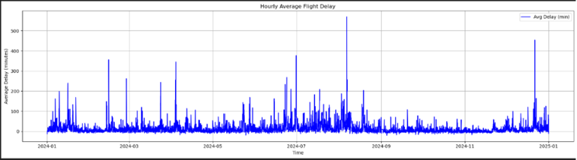
Figure 1: 1-Hour Intervale Time Series Data
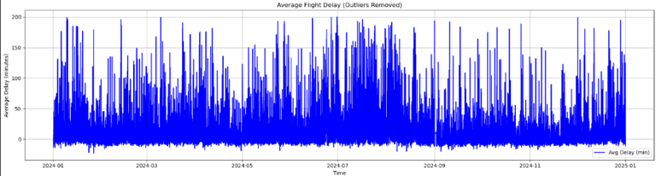
Figure 2: 15-Minute Interval Time Series Data with Outliers Removed

Deep Learning Models
Six architectures were tested, each representing a different viewpoint for time-series modeling. The CNN model captures short-term local patterns using sliding convolutional filters. The simple RNN provides a baseline for recurrent modeling but is known to struggle with long-term dependencies. LSTM and GRU networks were included because they are designed to overcome vanishing gradient issues and maintain memory over longer sequences. TCNs were also tested since they use dilated causal convolutions to capture wide temporal context without relying on recurrence. Finally, a Transformer model was implemented using multi-head attention, due to its ability to learn relationships between time steps regardless of distance.
Each model was trained using the Adam optimizer and mean squared error loss. The core hyperparameters tuned across all architectures included batch size, dropout, epochs, and learning rate, while additional model-specific parameters such as filters, kernel size, units, number of filters, feed-forward dimensions, number of attention heads, and embedding dimensions were tuned where relevant. Early stopping was also used to avoid overfitting.
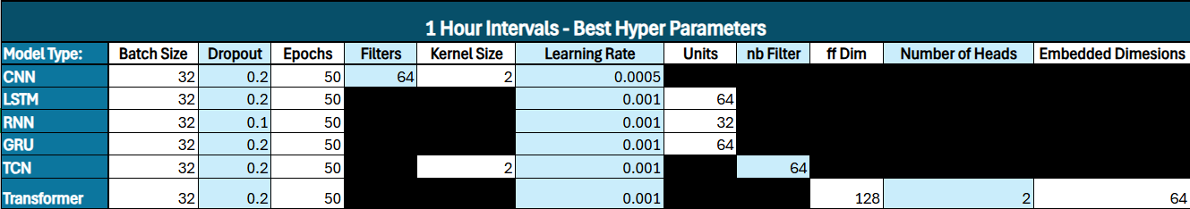Table 1: 1 Hour Interval Best Hyperparameters
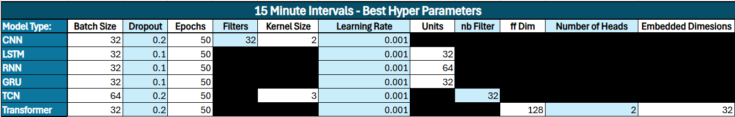Table 2: 15 Minutes Interval Best Hyperparameters
A focused range of hyperparameters were selected to balance computational efficiency with performance improvements. The number of units (32 and 64) allowed a comparison of smaller and moderately complex recurrent layers without overfitting the relatively small dataset. Dropout values of 0.1 and 0.2 provided light regularization suitable for real-world noisy delay data. Learning rates of 0.001 and 0.0005 were chosen because they are stable defaults for Adam and tested faster versus more controlled convergence. Batch sizes of 32 and 64 offered efficient training while capturing different gradient behaviors. Finally, training was fixed at 50 epochs with early stopping implemented during tuning to keep the comparison consistent across all models.
Model-specific parameters were also tuned within practical ranges. Convolution-based models (CNN and TCN) used filters of 32 or 64 and kernel sizes of 2–3, which are appropriate for capturing short-term temporal patterns. Recurrent models (RNN, LSTM, GRU) were tuned with 32 or 64 units, allowing comparison between smaller and more expressive sequence models. The Transformer model included tuning for embedding dimensions (32 or 64), feed-forward size (64 or 128), and attention heads (2 or 4), which offered enough capacity to learn long-range dependencies without overfitting.

Results

Results on Hourly Data
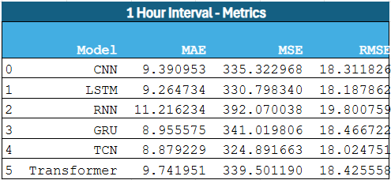
Figure 3: Results from 1-Hour Interval Dataset

Using the hourly-averaged dataset, the TCN model achieved the best performance among all architectures. It produced the lowest MAE and RMSE values, outperforming LSTM, GRU, and Transformer models. This makes sense because the hourly dataset still contains noticeable fluctuations and large jumps from one hour to the next, which created the type of multi-scale structure that TCNs are good at extracting. The dilated convolutions in a TCN allow it to see patterns across several hours simultaneously, which likely helped it capture rising and falling trends in airport flight delay times.
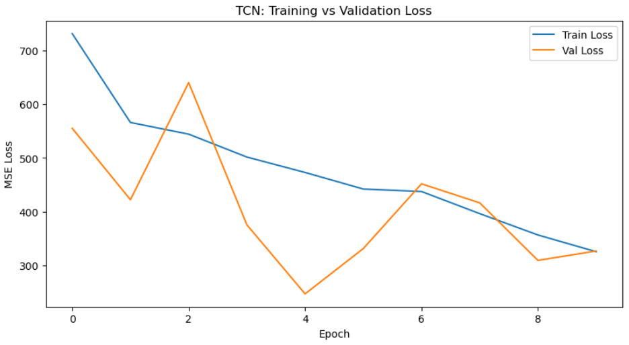
Figure 4: TCN Training vs Validation Loss from 1-Hour Dataset
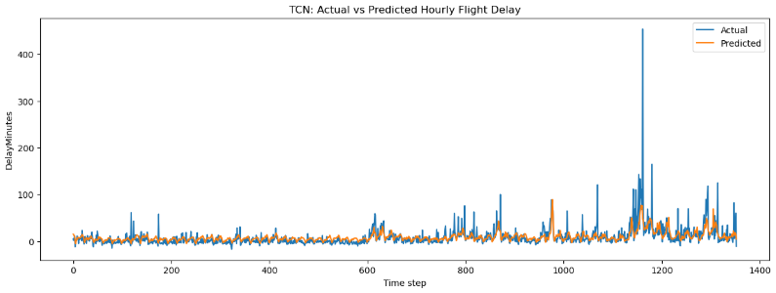
Figure 5: TCN Actual vs Predicted Results on 1-Hour Interval Test Set
Compared to TCN, the CNN model performed reasonably well but lacked the ability to model dependencies beyond a few hours. LSTM and GRU also performed strongly, which is expected, given their ability to store longer temporal information. The Transformer model performed similarly to LSTM and GRU, although it did not surpass them, likely because the dataset was still too small for attention mechanisms to be fully leveraged. The simple RNN performed the worst, as expected.

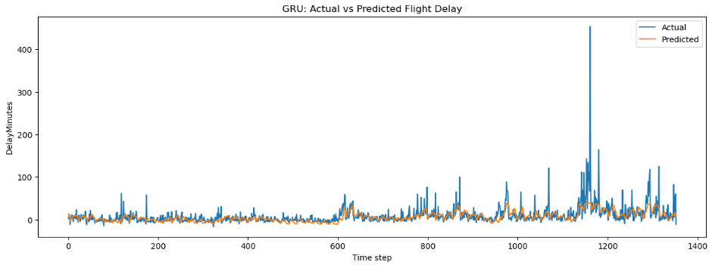
Figure 6: GRU Actual vs Predicted Results on 1-Hour Interval Test Set
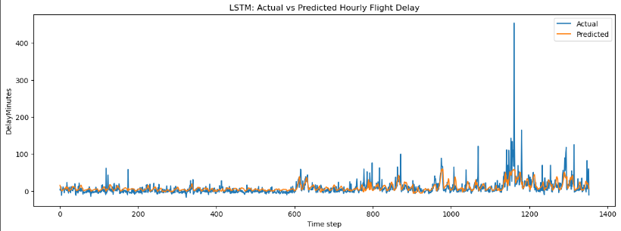
Figure 7: LSTM Actual vs Predicted Results on 1-Hour Interval Test Set
Overall, the hourly results were promising, but model behavior suggested that many networks were not fully utilizing their capacity due to the limited number of samples. This observation motivated the shift to 15-minute intervals.

Results on 15-Minute Data
After switching to 15-minute intervals, the metrics exhibited noticeable change. All models, except one, performed within a similar range, achieving MAE values of 11–12 minutes and RMSE values around 19 minutes. This grouping is consistent with the idea that the 15-minute dataset is smoother and easier to learn from than the hourly dataset. With more data points and reduced noise, many of the models stabilized and converged toward similar levels of performance.
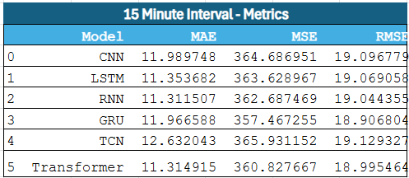
Figure 8: Results from 15-Minute Interval Dataset
The most surprising finding was the decline in the TCN model. While it had been the strongest architecture in the hourly experiment, it became the worst performer when 15-minute intervals were used. The reason for this change appears to be related to how TCNs handle temporal structure. When delays were averaged every hour, the dataset still contained abrupt variations with sudden increases or decreases in airport congestion, that behavior aligned well with the TCN’s ability to capture multi-scale patterns through dilated convolutions. Once 15-minute intervals were used, the time series became much smoother. There were fewer sharp transitions and fewer pronounced shifts across wider time spans. As a result, the dilation structure of the TCN no longer matched the underlying pattern in the data, causing it to lose the advantage it previously had.
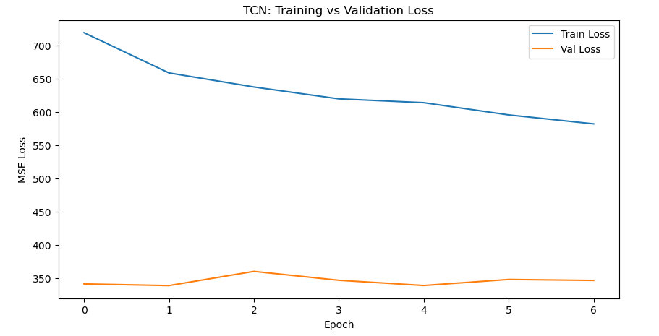
Figure 9: TCN Training vs Validation Loss on 15-Minute Interval Dataset
Meanwhile, LSTM, GRU, RNN, and Transformer models performed consistently across both datasets. Their architectures adapt well to smoother, medium-resolution data, and the increase in sample size benefited them. The RNN even improved slightly because the smoother input series reduced the impact of vanishing gradients. The CNN remained stable, although it still lacks access to long-term dependencies.
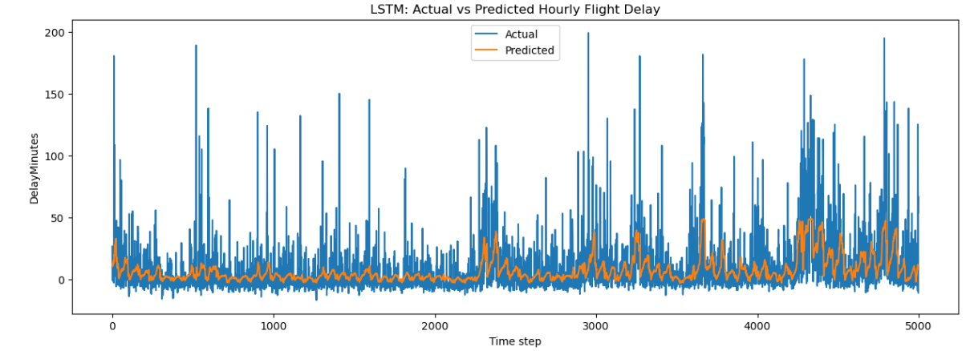
Figure 10: LSTM Actual vs Predicted Results on 15-Minute Interval Test Set
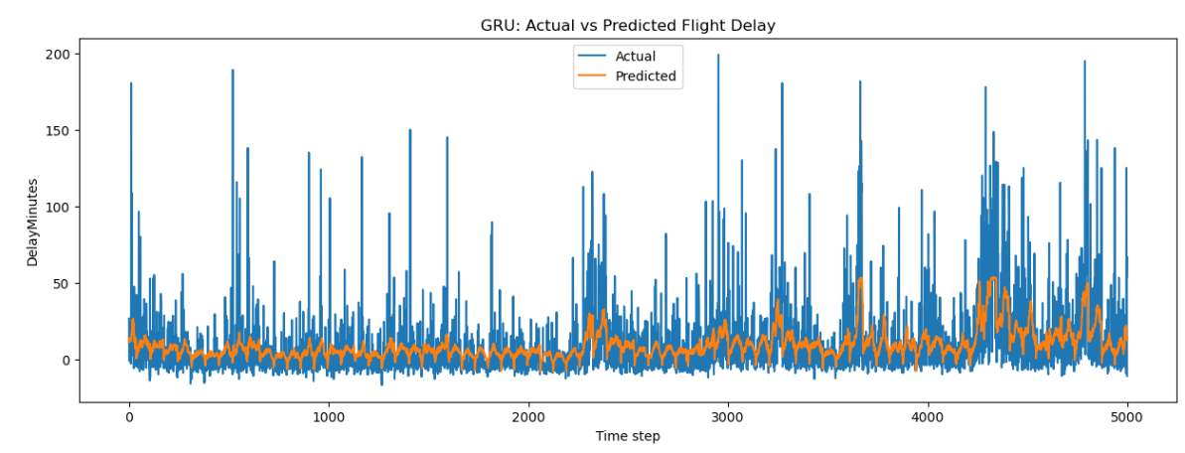
Figure 11: GRU Actual vs Predicted Results on 15-Minute Interval Test Set
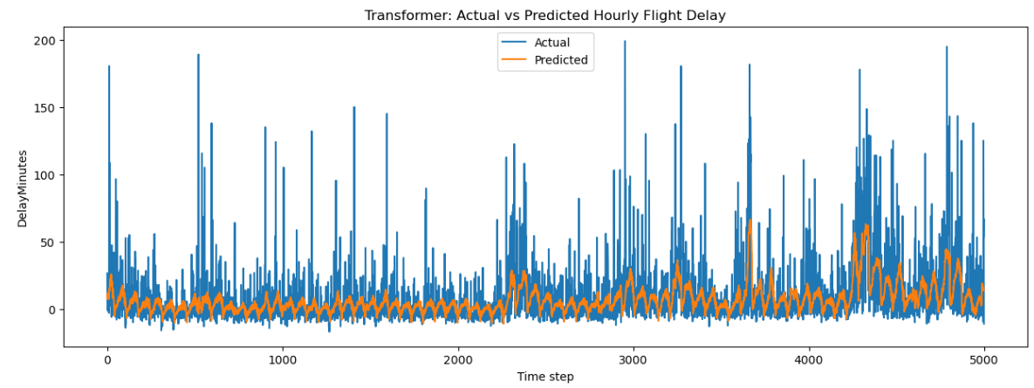
Figure 12: Transformer Actual vs Predicted Results on 15-Minute Interval Test Set

Discussion

Key Takeaways
One of the most important lessons from this project was how much effort went into preprocessing the data rather than training the models themselves. Choosing whether to aggregate delays hourly or every fifteen minutes, deciding how to smooth the data, and removing irregularities all played a major role in shaping the results. These decisions determined how much variability the models saw, how far back they needed to remember patterns, and how easily they could extract structure from the time series. It became clear that preprocessing was not just a setup step but a central part of the modeling pipeline.
The performance differences between the two temporal resolutions illustrated this clearly. In the hourly dataset, models designed to handle long-range temporal dependencies performed best. The TCN recorded the lowest MAE at 8.879, followed closely by GRU with an MAE of 8.956 and LSTM at 9.265. Simpler architectures such as CNN and RNN trailed behind, with the RNN reaching an MAE of 11.216 due to its difficulty preserving information across long sequences. Once the dataset was reprocessed into fifteen-minute intervals, the behavior of the models changed significantly. The smoother sequence and the larger number of samples caused most architectures to cluster closely together, with MAE values between roughly 11.3 and 12.0 and RMSE values hovering around 19.0. LSTM, RNN, GRU, CNN, and the Transformer all performed within a narrow band, while the TCN, which thrived at the hourly scale, now produced the highest MAE at 12.632 because the reduced variability made its dilation structure less effective.
These results underscored how strongly model performance depends on the alignment between architecture and data granularity. The TCN’s drop from the best performer at the hourly scale to the weakest at the fifteen-minute scale highlighted how a change in temporal resolution can completely reorder model rankings. At the same time, the convergence of most models around similar error levels in the finer dataset showed that smoother, higher-frequency data can reduce architectural differences and produce more stable performance overall. Importantly, although the fifteen-minute predictions were slightly less accurate numerically, they were far more actionable for real-time forecasting. Taken together, the project demonstrated that effective time-series forecasting depends on a combination of well-prepared data, appropriate temporal resolution, and model architectures that match the structure of the underlying patterns.

Future Improvements
The results suggest that the next step for this project is to strengthen the models by expanding both the depth and the quality of the training data. Although the hourly and fifteen-minute experiments produced different performance patterns, both would benefit from larger datasets that allow the models to learn more stable and reliable temporal relationships. This is especially important for architectures like the Transformer, which typically improve as the amount of training data grows. Incorporating additional features such as weather conditions, runway configurations, congestion indicators, and airline operational metrics would also give the models a more complete picture of the operational environment that drives fluctuations in delay. Implementing a form of anomaly detection to identify the outliers to remove from our dataset will also create a smoother dataset than the current methodology.

Another important direction is to refine the training process itself. More rigorous hyperparameter tuning, including searches over learning rates, sequence lengths, kernel sizes, and attention configurations, would help each architecture reach its full potential. The current results make clear that small changes in design and configuration can shift performance noticeably, so a more comprehensive tuning strategy could further reduce error.

Conclusion
This project demonstrated that deep learning can be used effectively to forecast short-term airport delays. Through experiments on both hourly and 15-minute datasets, it was found that the best model depends heavily on the structure and resolution of the time series. TCNs performed best on hourly data due to their ability to learn from large, abrupt fluctuations. However, their performance dropped sharply when the data was smoothed into 15-minute intervals. In contrast, LSTM, GRU, RNN, and Transformer models remained stable and produced reliable predictions across both time scales.
These findings highlight the importance of data preprocessing and temporal resolution in time-series modeling. Choices in how the data is aggregated can change the learning dynamics of deep networks. Ultimately, the models developed in this project, especially on the 15-minute data, show strong potential for helping passengers estimate airport congestion and plan their travel more confidently.

References

Datasets
Main Dataset:
M. Umar, “Flight Delays Dataset,” Kaggle.com, 2024. https://www.kaggle.com/datasets/umeradnaan/flight-delays-dataset (accessed Dec. 05, 2025).

Secondary Dataset:
H. Patil, “Flight Delay Dataset — 2024,” Kaggle.com, 2024. https://www.kaggle.com/datasets/hrishitpatil/flight-data-2024

External References

[1] “OST_R | BTS | Transtats,” Bts.gov, 2011. https://www.transtats.bts.gov/HomeDrillChart.asp Figures and Tables

Code Access Link
https://github.com/alexislitt6/4010_Final_Project

Gruop Member Contributions

All group members contributed evenly to the dataset selection and meetings to define our project goals and our problem statement. All group members also attended meetings to practice the final presentation and provide feedback and ideas to one another while preparing individual parts. Below is a list of each members individual contributions beyond this:

Alexis Litt:
- Initial testing of data reduction strategies
- CNN Model code
- Problem Statement / Motivation / Objective section of presentation
- Section I of report
Branka Verhoeven:
- Dataset preprocessing
- Machine Learning Models Code
- Training/Computing Models
- Section III and IV of final report
- Models & Results section of presentation
Quinn Cacilhas:
- Dataset preprocessing code
- Feature Engineering
- Dataset and preprocessing section of presentation
- Section II. of report
- Final Overall Report Edit
Serah Quinn:
- Original Model Evaluation code
- RNN Model code
- Discussion of Results section of presentation
- Section V. and VI. of report

